**Lab Report No : 05**

**Lab Report Name : Connecting a database (MySQL) with Linux**

1. **Install MySQL on Ubuntu**

**Answer** : At first go to terminal and run the command –

*‘sudo apt-get install mysql-server’*

Then the command prompt will ask for your linux password.

After giving your password the process for installing MySQL will start. Make sure you have a stable internet connection. After finishing installing MySQL give the command –

*‘sudo mysql_secure_installation’*

Then complete the personalization process.

1. **Log into MySQL by Linux :**Start MySQL in your Linux. Give the command –

*‘sudo mysql –u root –p’*

And give your MySQL password.

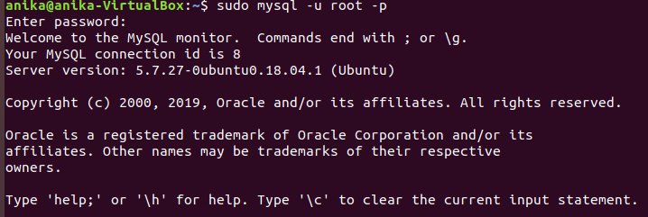

1. **Create Database Table :**

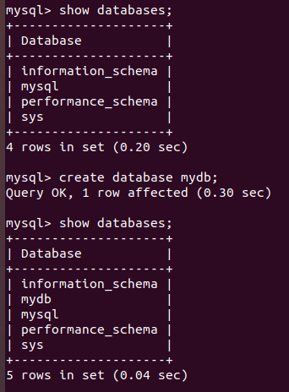

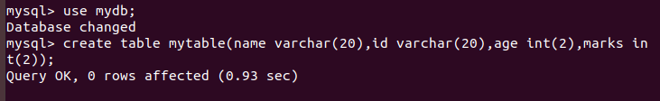

1. **Insert Data into table :**

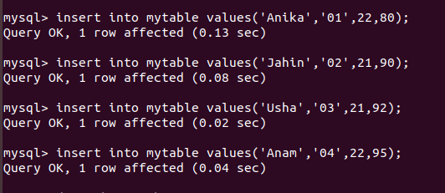

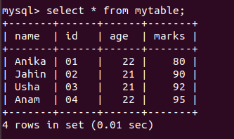

1. **Describe Table :**

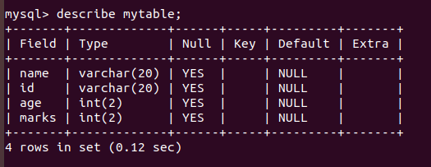

1. **Alter Table :**

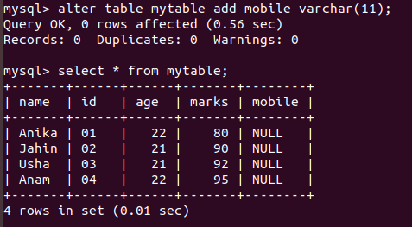

1. **Modify Table :**

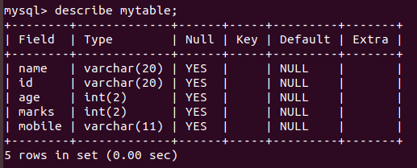

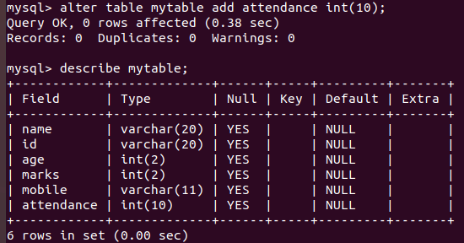

1. **Drop Data from Table :**

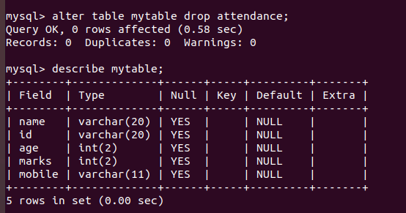

1. **Update Data of Table :**

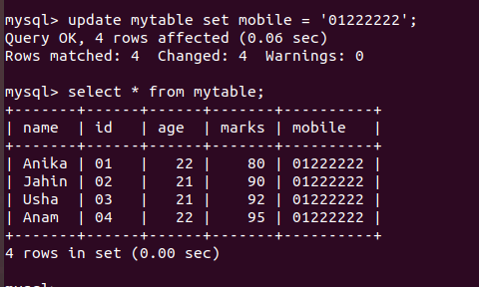

1. **Where and Delete operation :**

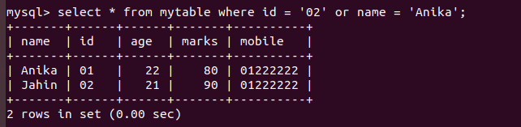

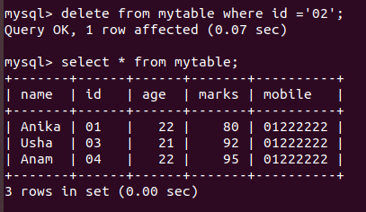

**Description :** MySQL is the world's most popular open source database. With its proven performance, reliability and ease-of-use, MySQL has become the leading database choice for web-based applications, used by high profile web properties including Facebook, Twitter, YouTube, Yahoo! and many more.

Oracle drives MySQL innovation, delivering new capabilities to power next generation web, cloud, mobile and embedded applications.